1. Merge Two Sorted Lists

CODE:

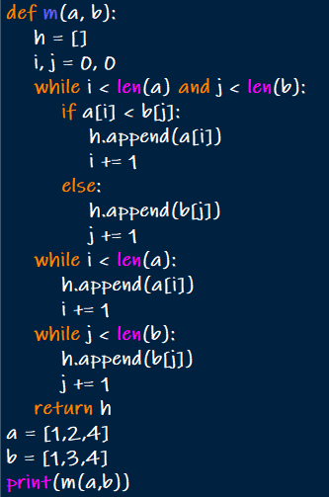

OUTPUT:



1. Merge k Sorted Lists

CODE:

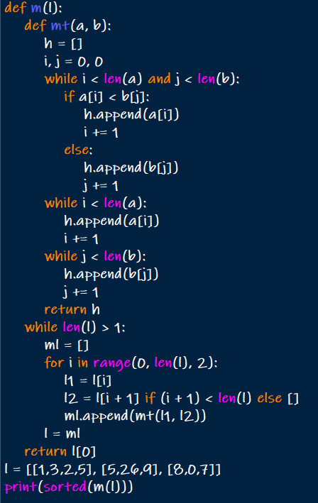

OUTPUT:



1. Remove Duplicates from Sorted Array

CODE:

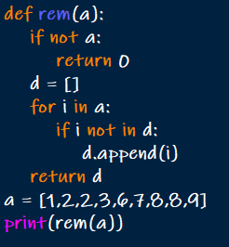

OUTPUT:



1. Search in Rotated Sorted Array

CODE:

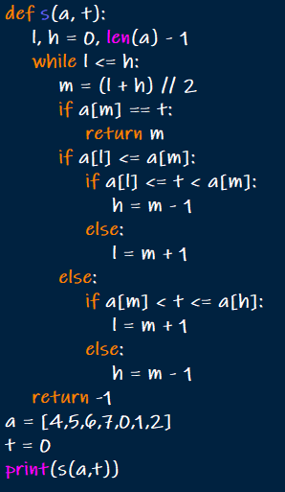

OUTPUT:



1. Find First and Last Position of Element in Sorted Array

CODE:

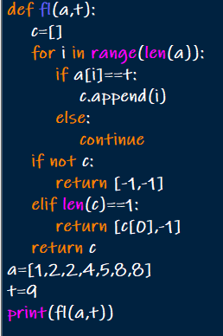

OUTPUT:



1. Sort Colors

CODE:

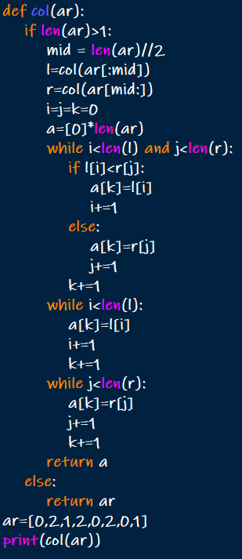

OUTPUT:



1. Remove Duplicates from Sorted List

CODE:

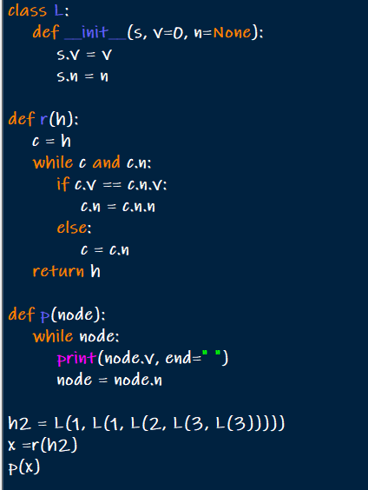

OUTPUT:



1. Merge Sorted Array

CODE:

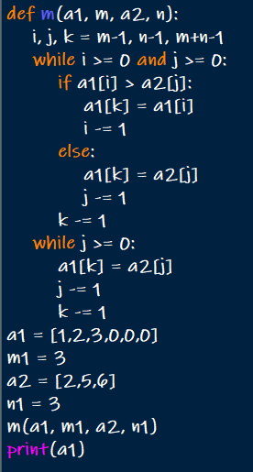

OUTPUT:



1. Convert Sorted Array to Binary Search Tree

CODE:

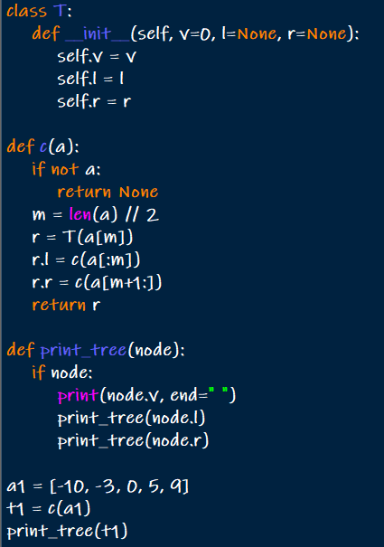

OUTPUT:



10.Insertion Sort List

CODE:

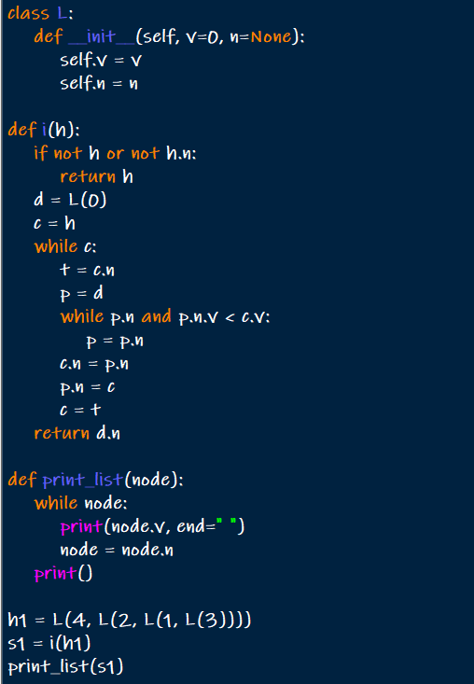

OUTPUT:



11. Sort Characters By Frequency

CODE:

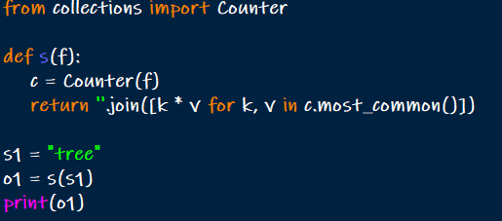

OUTPUT:



1. Max Chunks To Make Sorted

CODE:

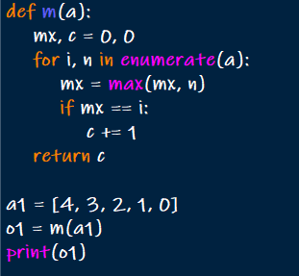

OUTPUT:



1. Intersection of Three Sorted Arrays

CODE:

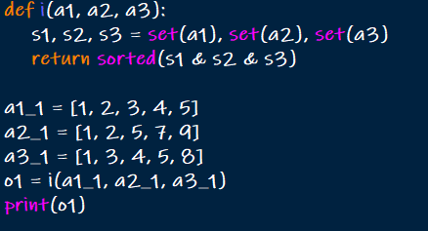

OUTPUT:



1. Sort the Matrix Diagonally

CODE:

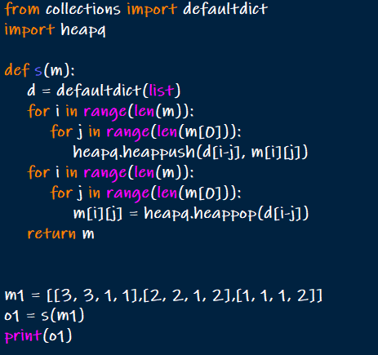

OUTPUT:

